Objective:
Use Subqueries, CTEs, and Window Functions to analyze sales data from the Superstore dataset.

Tasks

Step 1: Setup Data
- Import the Superstore dataset into a table named superstore_raw.
- Create these 3 tables from it:
  - customers
  - orders
  - products
- Insert data into these tables using SELECT DISTINCT.

Step 2: Perform Required Queries
Write and execute SQL queries for each of the following:
- Find all orders where sales are greater than the average sales. (Subquery)
- Find the highest sales order for each customer. (Subquery)
- Calculate total sales for each customer. (CTE)
- Find customers whose total sales are above average. (CTE + Subquery)
- Rank all customers based on total sales. (Window Function)
- Assign row numbers to each order within a customer. (Window Function + PARTITION BY)
- Display top 3 customers based on total sales. (Window Function)

Step 3: Final Combined Query
Write one final query that shows:
- Customer Name
- Total Sales
- Rank
(Use JOIN + CTE + Window Function together)

Mini Project: Customer Sales Insights
Answer the following using SQL:
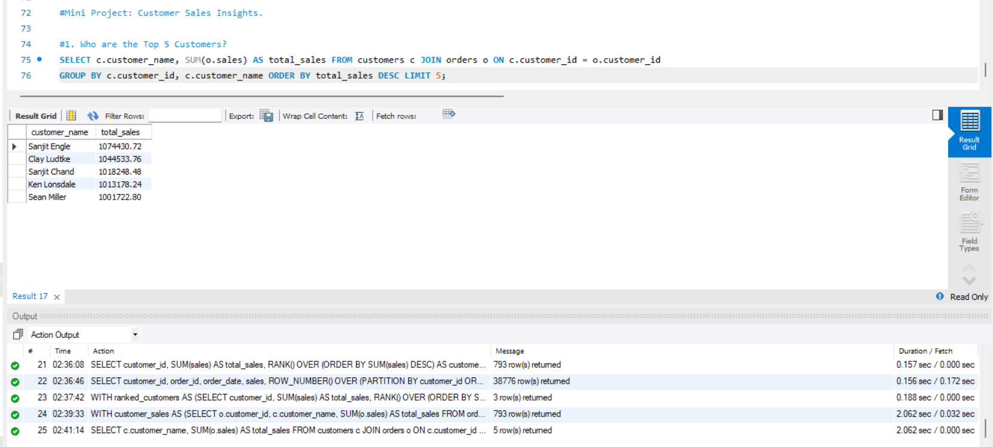
- Who are the top 5 customers?

- Who are the bottom 5 customers?
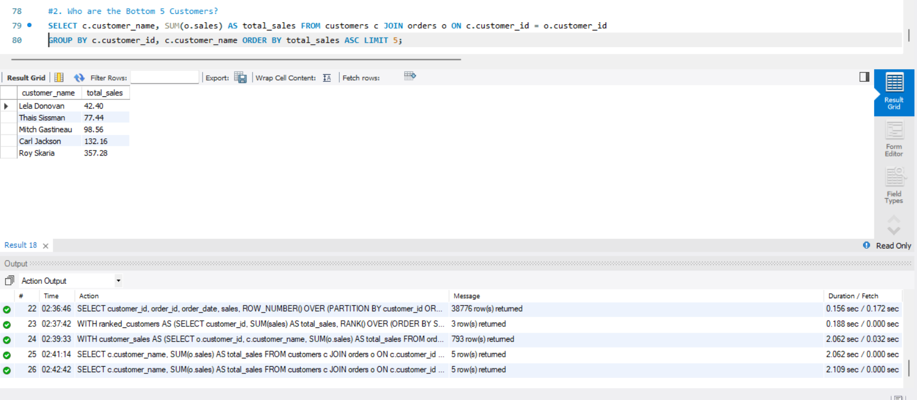

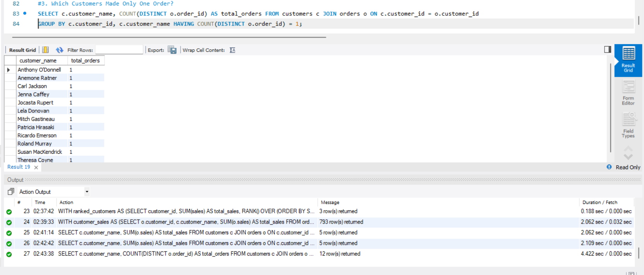
- Which customers made only one order?

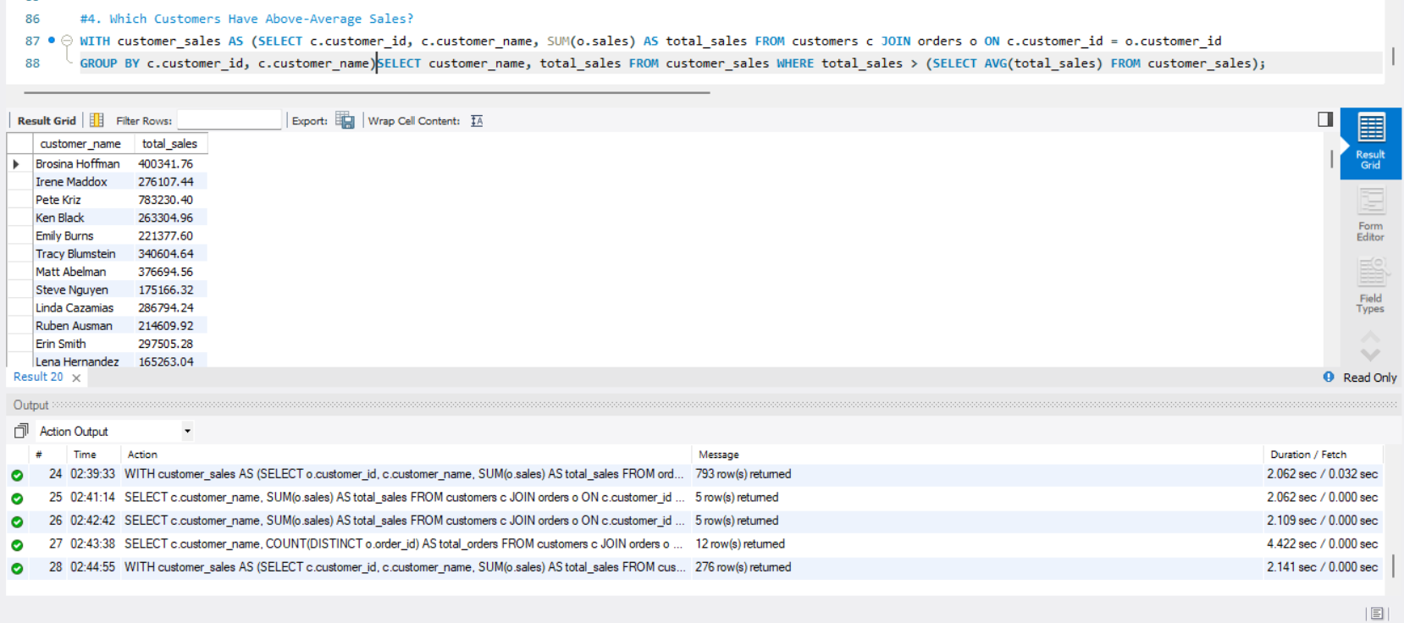
- Which customers have above-average sales?

- What is the highest order value per customer?
